- Given a list of delivery times (in minutes) for 20 Zomato orders, calculate the 25th, 50th, and 75th percentiles using Python's numpy.percentile function.
ANSWERS:
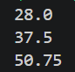

- Create a Python script that takes an array of IPL player scores and divides them into quartiles using numpy.quantile. Print the values for Q1, Q2 (median), and Q3.
ANSWERS:
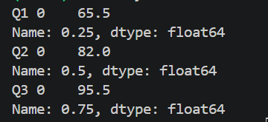

- Given a list of daily step counts from your fitness app for one month, calculate the Interquartile Range (IQR) in Python and explain what it tells you about your activity consistency.
Hint: IQR = Q3 - Q1
ANSWERS:
- Write a Python function to detect outliers in a list of Swiggy order amounts using the IQR method (any value below Q1 - 1.5*IQR or above Q3 + 1.5*IQR). Print the outlier values.
ANSWERS:

